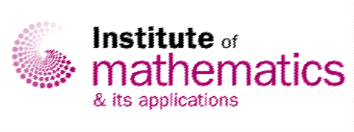

ECM Networking Icebreaker at the BAMC 2022

10th April, Loughborough University
Timings: 4-7pm

https://ima.org.uk/18904/ecm-networking-icebreaker-at-the-bamc-2022/

Welcome to the icebreaker event for Early Career Mathematicians (ECM) at the BAMC 2022, sponsored by the ECM Committee of the Institute of Mathematics and its Applications (IMA). Feedback we received from our members is that networking and forming contacts with others at conferences is daunting but improves enjoyability of the conference. Forming contacts is what we want to facilitate at this event. This event is being run in a parallel format, we will host the event in Burleigh Court and run the same activities on Spatial.chat independently of each other.

We will start the event with speeches on the history of the BAMC and ECMs, followed by what the ECM Committee does and information about the IMA. Then we will start the activities, which include:

- Mathematical Taboo
- Mathematical Headbandz
- Celebrity Cameo
- Group discussions on topics such as memorable moments during your PhD and your first conference experience

Refreshments will be supplied and you are welcome to join the ECM Committee for an informal dinner after the event.

Programme

4.00pm – 4:15pm Arrival
4:15pm – 4:30pm Speeches
4:30pm – 6:45pm Activities

Registration Information

This event will run in person and online at the same time but independently to each other, please make sure you select the correct rates.

IMA Member £10
Non-IMA Member £20
IMA Students £5
IMA eStudents £5
Non-IMA Students £10

Register here for the ECM Networking Icebreaker

Registration will close on the 4 April.

Contact information
For general conference queries please contact the Conferences department. Email: conferences@ima.org.uk Tel: +44 (0) 1702 354 020.
Institute of Mathematics and its Applications, Catherine Richards House, 16 Nelson Street, Southend‐on‐Sea, Essex, SS1 1EF

